This guide is meant to provide the safe and correct way to jump start your car and can be used if the owner’s manual for the vehicle is not available. PLEASE CONSULT THE OWNER’S MANUAL OF THE CAR IF IT IS AVAILABLE FOR JUMP STARTING INSTURCTIONS BEFORE USING THESE INSTRUCTIONS.
First, position the car with the good battery as close to the car with the dead battery that will allow for your jumper cables to easily reach between the cars with little or no tension on them. After you get the cars parked close enough where a connection can be made, make sure both cars are completely shut off. Yes, that means the car with the dead battery as well. If the dead car’s ignition is on, then you have more of a load than just a dead battery. So when you make the connection to the good car, you will have sparks, and sparks are scary.
CABLE CONNECTION ORDER
Once the cars are in the right place and turned all the way off, you can start connecting the cables. First, take one lead of the positive cable (usually marked in red or orange) and connect it to the positive terminal (+) of the dead battery. Next, take the other side of that same positive cable and connect it to the positive terminal (+) of the good battery. Now, take one lead of the negative jumper cable (almost always marked in black) and connect it to the negative terminal (-) on the good battery. The last remaining negative jump lead would go to, preferably, a ground point on the dead car. If that can’t be found then it goes straight to the negative battery terminal. (-)
Step 1: Attach one end of the positive cable (RED) to the dead battery’s positive terminal:
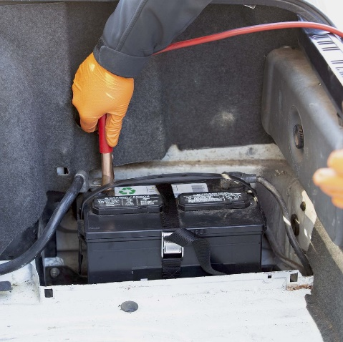
Step 2: Take the other end of the positive cable (RED) and attach it to the support car’s positive battery terminal.
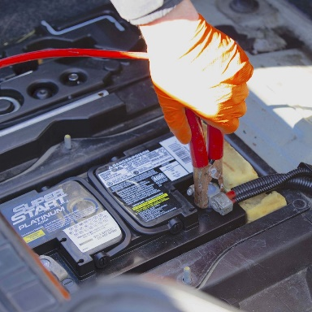

Step 3: Take one end of the negative jumper cable (BLACK) and attach it to the good battery’s negative terminal.
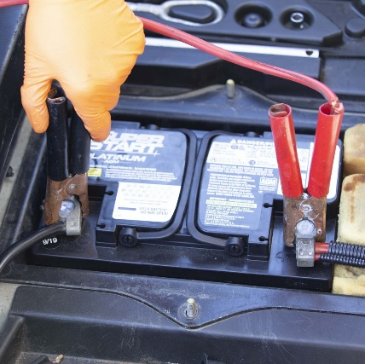
Step 4: Attach the other end of the negative cable (BLACK) to the dead car’s negative battery terminal.
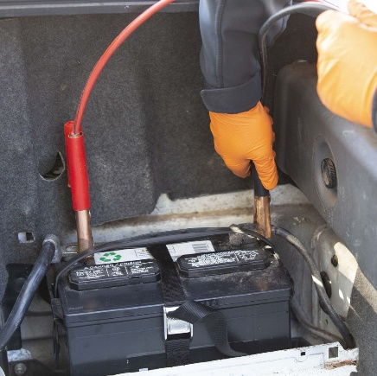
Make sure all four leads have good, solid connections to their jump points. You don’t want any of them popping off if you bump into the wires or either of the cars. After that’s done, start the car with the good battery. Let it run for about 5 minutes. The alternator of the good car will charge up the dead battery. After that, you can go ahead and attempt to start the car with the dead battery. If you’ve done everything right (and the dead car is in good health), it should start right up.
After giving it 5 minutes, the car with the dead battery should start normally.
Once the dead car is running, hop out and disconnect the cables in the opposite order you connected them. You don’t have to rush this part. Having both cars running with the batteries connected won’t do any immediate harm.
DO NOT shut the car with the formerly dead battery off until you are in a place that is safe and where you know you can get help easily just in case there are other issues with the battery that prevent it from staying charged. Driving the car will help charge it fully. If you are parking the car in a parking space or garage, it is better to back into the space so the front of the car is facing out which will make towing the car or jumping it again easier if that is necessary.

