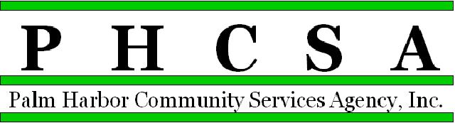

EAST LAKE COMMUNITY LIBRARY
Library Assistant II – Circulation Department
P/T – 20-24 hours per week
Pay commensurate with experience
Return completed application to the front desk at East Lake Community Library, Attn. Circulation Supervisor Heather Brown or scan to Circulation Supervisor’s Email
Heather-b@eastlakelibrary.org.

The duties below are representative of the duties of the position and are not intended to cover all the duties performed by incumbents of any particular position.

DEFINITION

This paraprofessional position involves responsibility for performing technical library tasks approaching a professional level through the application of skills and knowledge acquired by special study and training. An employee in this category exercises considerable judgment and discretion in performing advanced library duties. Employee may be responsible for coordinating or assisting with library programming. Continuous public contact requires the exercise of considerable patience, tact and diplomacy. Work is performed under supervision of a department head and is reviewed through conference, personal observation of performance, and inspection of work by the department head.

MINIMUM QUALIFICATIONS

Education and Experience: High school diploma or GED required and TWO (2) years library experience, one of which must be in the area assigned. Bachelor's degree desirable. Computer experience is required.
Must be able to stand/walk during shift for approximately 3 hours, as well as easily lift 10 pounds and
push/pull book/equipment cart.

Knowledge and Abilities:
- Ability to work evening and weekend hours.
- Ability to deal with various duties simultaneously.
- Knowledge of reader interests and of books and authors.
- Skill in the use of personal computers and standard office equipment.
- Ability to effectively search on-line catalogs and other databases.
- Familiarity with current library technology.
- Ability to establish and maintain effective working relationships with employees, volunteers and patrons.
- Ability to communicate clearly and concisely, both orally and in writing.
- Ability to evaluate information retrieved.
- Ability to sort and file alphabetically and numerically.

---------------------------------------------------------------------------------------------------------------------------------------

Library Assistant II - Circulation

Knowledge and Abilities:

- Ability to understand circulation functions and working knowledge of library operations
- Ability to make independent work decisions based on experience and knowledge of departmental operations and customer service
- Ability to sort and file alphabetically and numerically.

Additional Responsibilities:

- Ability to deal with various duties simultaneously
- Ability to establish and maintain effective working relationships with employees, volunteers and patrons

I have read, understand and am able to perform the job description without additional accommodations.

Signature Date

2/6/2023.hnb

