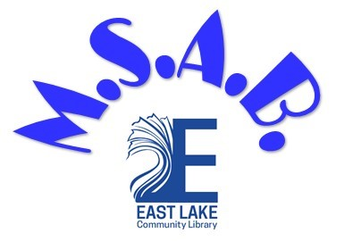

MIDDLE SCHOOL ADVISORY BOARD GUIDELINES

Definition and Structure:
The Middle School Advisory Board (MSAB) of East Lake Community Library, under the guidance of the Youth Services Department staff members, will offer their time in the creation, planning, and implementation of various activities for middle school aged patrons. Members will also have the opportunity to gain necessary skills and insights that will prepare them to be members of our Teen Advisory Board upon entering high school.

Conduct and Behavior:
Members of the Middle School Advisory Board are expected to be kind and respectful to one another in a mature fashion while representing the East Lake Community Library during meetings and events. They are subject to all existing library policies regarding internet and material usage, and Code of Conduct while in the library.

Volunteer Hours:
Members will be required to attend the monthly meeting and will earn volunteer and/or service hours for the meetings as well as the events they help plan and run.

Meetings:
- The Middle School Advisory Board will run September through April. Meetings will be held monthly at the East Lake Community Library.
- MSAB meetings will have a casual, welcoming, and respectful atmosphere that will allow for discussion and comments by all members. MSAB members will show respect for the library staff, patrons, other members and guests.
- If an MSAB member will not be able to make a meeting, they must notify Valerie Rosello. If two (2) meetings are missed without prior notification, the member’s position on the Board will be discussed.
-
Valerie Rosello
Teen Coordinator
727-773-2665
valerie-r@eastlakelibrary.org

