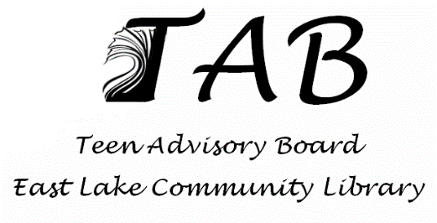

TEEN ADVISORY BOARD GUIDELINES

Mission and Purpose:
The East Lake Community Library Teen Advisory Board will help to meet one of our library’s fundamental goals of bringing more teen patrons into the library. This will involve teen volunteers (14-18 years old) taking responsibility for creating, planning, and running teen programs and events the library supports. Teen Board members will learn about the purpose and function of our library as well as help with events and assist patrons when necessary. The primary mission of the Teen Advisory Board of East Lake Community Library is to inspire students ages 14-18 to become life-long users of the library and give teens a place to express their opinions, make friends, and connect with the community.

Definition and Structure:
The Teen Advisory Board (TAB) will be a teen governed and teen driven group of 14-18 year olds. It will be comprised of young men and women who are registered volunteers at East Lake Community Library and it will be mentored by the Teen Coordinator and members of the Youth Services Department.

Financial Structure:
The Teen Advisory Board will receive some funds from the library’s annual budget and the Friends of East Lake Community Library, but it will work to raise funds from their own planned events. Money may be collected at some programs for entry, concessions and/or fundraising.

Conduct and Behavior:
Members of the Teen Advisory Board are expected to be kind and respectful to one another in a mature fashion while representing the East Lake Community Library during meetings and events. They are subject to all existing library policies regarding internet and material usage, and Code of Conduct while in the library.
Officers:
Teen Advisory Board Officers must meet the membership guidelines. They are to make a request to become an Officer in writing (a short statement of intent). They will pledge to make special effort to attend all meetings and TAB sponsored events. They will pledge to devote time and effort beyond monthly General Meetings and will serve for one school year.
Elected Positions:
President: The President of TAB will work closely with the Mentor and fellow Officers and Board Members to organize and preside over TAB meetings.
Vice-President: The Vice-President of TAB will serve as acting president in his/her absence. The Vice-President will assist the Mentor and President in facilitating all TAB meetings.
Secretary: The Secretary will be responsible for attendance sheets at all meetings. The Secretary will read highlights from previous meetings and will take minutes at each meeting. Minutes from each meeting should be shared with all TAB Members and Teen Coordinator; this can be done via e-mail or however the Secretary and Teen Coordinator deem most effective.

Elections:
Each April, at the last general meeting of the month, new elections will be held. Members will be voted on by secret ballot and tallied by the Teen Coordinator. There is no limit on the amount of terms a member may serve and only TAB Members will be allowed to vote in elections. Newly elected Officers can work with current Officers during the month of May, but will begin their terms in September.

Volunteer Hours:
Because the Teen Advisory Board will count towards Bright Futures Scholarship hours, members will be required to attend at least one meeting per month. Volunteers will receive Bright Future Scholarship hours for the meetings as well as the events they help plan and run.

Meetings:
- The Teen Advisory Board will run September through May. Meetings will be held at the East Lake Community Library on days/times agreed upon by the TAB and TAB Mentor.
- TAB meetings will have a casual, welcoming, and respectful atmosphere that will allow for discussion and comments by all members. TAB members will show respect for the library staff, patrons, other members and guests.
- If a TAB member will not be able to make a meeting, they must notify a TAB Officer or TAB Mentor. If two (2) meetings are missed without prior notification, the member’s position on the Board will be discussed.
Valerie Rosello
Teen Coordinator
727-773-2665
valerie-r@eastlakelibrary.org

