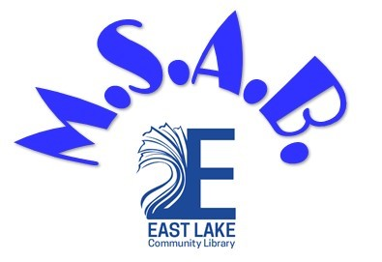

MIDDLE SCHOOL ADVISORY BOARD APPLICATION

Please print:

Name: _______________________________________________________________

Birthday: ____ /_____ /____ Age: _________

School Attending: _______________________________________________ Grade: ________

Phone number: (______) ______ - ________ ( __Personal Cell __Home)

Are you able to receive text messages? __Yes __No

Email (Please print clearly!): ________________________________________________________

What is the best way to contact you? ___Text ___E-mail ___Phone Call

I have been made aware of the Middle School Advisory Board Guidelines. By signing this application, I agree to comply with the policies and procedures outlined in the Guidelines.

Signature: _________________________________________________ Date: ________________
East Lake Community Library
4125 East Lake Road
Palm Harbor, FL 34685
727-773-2665

